NAME: Ondřej Marvan, 477001
This lecture report will focus on the subjective evaluation of the model inserting taxes on the perfectly competitive market and the influence of taxes on demand for labour, profits and production on a typical firm. You will have instant visualization of many functions. Based on them, you should assess their external validity. Remember that the numbers (p, w) are artificial and do not interpret them – it is a problem of calibration of the function. You have to focus on the behaviour of the functions and interpret their behaviour.
In your exam, in some tasks, the input is personalised by N1 (4), N2 (7), N3 (7), N4 (0), N5 (0) the sequence of the first 5 digits from your student ID. Today we use only N1 (4) and N5 (0). But it will be enough to create many versions of the task. Only input it into the task and run the code. [sometimes to improve the quality of the graph you should change the graph option – intervals of drawing which are bolded in code].

Problem:
The production function of a typical company producing boxes of candies can be approximated by the formula Y(L)=500*(N1+N5 + 20)L^(0.5). The company operated in perfectly competitive conditions. The price of the box of candies is given p = (N1+N5 + 5). The market wages in this sector are w = 5100. How will the introduction of a tax on the firm (considered producing an unhealthy product) affect the demand for labour at a typical company? What will be the company’s production and profit levels? What is the optimal tax rate that maximizes tax revenue for the government? Furthermore, how will the optimal tax rate impact the company?
1) Extended Approach from Intermediate Microeconomics: calculate at least two equilibrium points and compare them.
First, I define my specific parameters based on N1 = 4 and N5 = 0:
Production Function Y (L): 500 * (4 + 0 + 20) * L^{0.5} = 12000 x L^{0.5}
Price p: (4 + 0 + 5) = 9
Wage w: 5100
The firm's profit maximilization condition (F.O.C.) is p * MP_{L} = w (or effective wage).
MP_{L} = $\frac{dY}{dL}$ = 12000 * 0.5 * L^{0.5} = 6000 * L^{-0.5} The baseline VMP_{L} = p * MP_L = 9 * (6000 * L^{0.5}) = 54000 * L^{-0.5}
Solution 54000 * L^^{-0.5} = (effective wage) for each case.

Baseline (No Tax) Calculation
Profit Pi: pY - wL = 108000 * L^{0.5} - 5100L
F.O.C.: 54000 * L^{-0.5} = 5100
L* (Labor): L^{0.5} = $\frac{54000}{5100}$ = $\frac{180}{17}$ => L* = 112.11
Y* (Production): 12000 * $(\frac{180}{17}$) = 127,058.82
Pi* (Profit): 108000 * ($\frac{180}{17}$) - 5100 * (112.11) = 571,764.71
T* (Tax Revenue): 0

The government believes that significant taxation on candy production is necessary. Four options are being considered:
a) A 20% sales tax on candy, based on the value of the product sold ( ad valorem tax on sales)
b) A 25% tax on profits.
c) A fixed tax of $3 per box of candies sold (per-unit excise tax)
d) A wage tax where employers must pay an additional $300 per employee, as the government believes wages are too high in this sector.
Baseline (No Tax) | A 20% Sales Tax | B 25% Profit Tax
Labor (L):*  The F.O.C. is VMP_L = w  54000 * L^{-0.5} = 5100  L^{-0.5} = 5100 / 54000 = $\frac{17}{180}$  L^{0.5} = 180 / 17  L* = (180 / 17)² = 112.11  Production (Y):*  Y* = 12000 * L^{0.5} = 12000 * (180 / 17) = 127,058.82  Profit (Pi):*  Pi* = (p * Y*) - (w * L*)  Pi* = (9 * 127058.82) - (5100 * 112.11)  Pi* = 1143529.38 - 571764.71 = 571,764.67 (This is 571,764.71 in your table)  Tax Revenue (T):*  T* = 0.00 | The effective price for the firm is p * (1-t) = 9 * (1 - 0.20) = 7.2  The new F.O.C. is p(1-t) * MP_{L} = w  New VMP_{L} = 7.2 * (6000 * L^{-0.5}) = 43200 * L^{-0.5}  Labor (L):*  43200 * L^{-0.5} = 5100  L^{-0.5} = 5100 / 43200 = $\frac{17}{144}$  L^{0.5} = $\frac{144}{17}$  L* = ($\frac{144}{17}$)² = 71.75  Production (Y):*  Y* = 12000 * L^{0.5} = 12000 * ($\frac{144}{17}$ = 101,647.06  Profit (Pi):*  Pi* = (p(1-t) * Y*) - (w * L*)  Pi* = (7.2 * 101647.06) - (5100 * 71.75)  Pi* = 731858.83 - 365925 = 365,933.83 (rounding difference)  Tax Revenue (T):*  Tax is $t$ * $p$ * $Y*$  T* = 0.20 * 9 * 101647.06 = 182,964.71 | The F.O.C. does not change. The firm maximizes pre-tax profit, so L* and Y* are the same as the baseline.  Labor (L):*  L* = 112.11 (same as baseline)  Production (Y):*  Y* = 127,058.82 (same as baseline)  Profit (Pi):*  First, find pre-tax profit = 571,764.71  Pi* = (1 - t) * (Pre-tax Profit)  Pi* = (1 - 0.25) * 571764.71 = 0.75 * 571764.71 = 428,823.53  Tax Revenue (T):*  T* = t * (Pre-tax Profit)  T* = 0.25 * 571764.71 = 142,941.18

C $3 Per-Unit Tax | D $300 Wage Tax
The effective price for the firm is (p - t) = 9 - 3 = 6  The new F.O.C. is (p-t) * MP_{L} = w  New VMP_{L} = 6 * (6000 * L^{-0.5}) = 36000 * L^{-0.5}  Labor (L):*  36000 * L^{-0.5} = 5100  L^{-0.5} = 5100 / 36000 = 17 / 120  L^{0.5} = 120 / 17  L* = (120 / 17)² = 49.83  Production (Y):*  Y* = 12000 * L^{0.5} = 12000 * (120 / 17) = 84,705.88  Profit (Pi):*  Pi* = ((p-t) * Y*) - (w * L*)  Pi* = (6 * 84705.88) - (5100 * 49.83)  Pi* = 508235.28 - 254133 = 254,102.28 (Your table has 254,117.65, again a small rounding difference)  Tax Revenue (T):*  T* = t * Y*  T* = 3 * 84705.88 = 254,117.64 | The effective wage for the firm is (w + t) = 5100 + 300 = 5400  The F.O.C. is VMP_{L} = (w+t)  Labor (L):*  54000 * L^{-0.5} = 5400  L^{-0.5} = 5400 / 54000 = 0.1  L^{0.5} = 10  L* = 10² = 100.00  Production (Y):*  Y* = 12000 * L^{0.5} = 12000 * 10 = 120,000.00  Profit (Pi):*  Pi* = (p * Y*) - ((w+t) * L*)  Pi* = (9 * 120000) - (5400 * 100)  Pi* = 1080000 - 540000 = 540,000.00  Tax Revenue (T):*  T* = t * L*  T* = 300 * 100 = 30,000.00

The government can pursue three different objectives:
- Fiscal – Maximizing tax revenues. Option (c) $3 Per-Unit Tax.** It generates the highest revenue ($254,117.65)

- Social – Minimizing sugar consumption and reducing candy production. Option (c) $3 Per-Unit Tax.** It results in the lowest production level ($84,705.88).

- Employment Stability – Maintaining the same number of workers employed. Option (b) 25% Profit Tax. It is the only tax that does not distort the labor decision, leaving employment unchanged at 112.11.

Which tax option is the best for achieving each of the three goals (1, 2, and 3 – answered above)? Is it possible to achieve all three goals simultaneously, or at least two out of three? Additionally, which of these taxes would be easiest to implement with the least social resistance? Provide a reasoned argument for your subjective assessment based on results.
- No, it is not possible to achieve all three goals. The goal of employment stability (b) is mutually exclusive with the goals of maximizing revenue and minimizing production (c).
- Yes, it is possible to achieve two goals. Option (c) $3 Per-Unit Tax achieves both the Fiscal and Social goals.

Check and correct the codes: i) insert your N-s ii) see if the taxation method declarations match the profit function record. iii) if there are any errors in the code.
Then compare the results you have, squeeze as much as you can from this information. How big is this tax burden - you can determine this by comparing it with other profit components. How does this model behave? You can experiment with the parameters.

a | b | c | d
kill(all);  assume(w >0,L>0,p>0,t>0);  N1:4;  N5:0;  w: 5100;  A: 500;  t: 0.20;  p: (N1+ N5 + 5);  /* enter the production function */  Y: A*(N1+N5 + 20)*L^(0.5);  /* enter the profit function */  Profit: p*(1-t)*Y - w*L$  /* calculate f.o.c*/  eq1: diff(Profit,L,1) = 0;  float(solve (eq1,L));  L : rhs(%[1]);  /* outputs */  print("t = ", ''t) $  print("p = ", ''p) $  print("L* = ", ''L) $  print("Y* = ", ''Y) $  print("Π* = ", ''Profit) $  print("T* = t*p*Y* = ", '' t*p*''Y) $  print("Cost of work = ", '' w*''L) $  print("Revenue = ", '' p*''Y) $  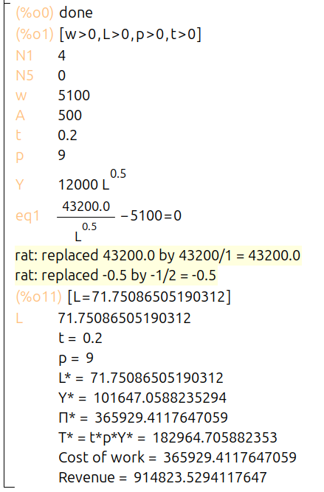 | kill(all);  assume(w >0,L>0,p>0,t>0);  N1:4;  N5:0;  w: 5100;  A:500;  t: 0.25;  p: (N1+ N5 + 5);  /* enter the production function */  Y: A*(N1+N5 + 20)*L^(0.5);  /* enter the profit function */  Profit: (1 - t)* (p*Y - w*L)$  /* calculate f.o.c*/  eq1: diff(Profit,L,1) = 0;  float(solve (eq1,L));  L : rhs(%[1]);  /* outputs */  print("t = ", ''t) $  print("p = ", ''p) $  print("L* = ", ''L) $  print("Y* = ", ''Y) $  print("Π* = ", ''Profit) $  print("T* = t*(p*Y - w*L) = ", '' t* (p*''Y - w*''L)) $  print("Cost of work = ", '' w*''L) $  print("Revenue = ", '' p*''Y) $  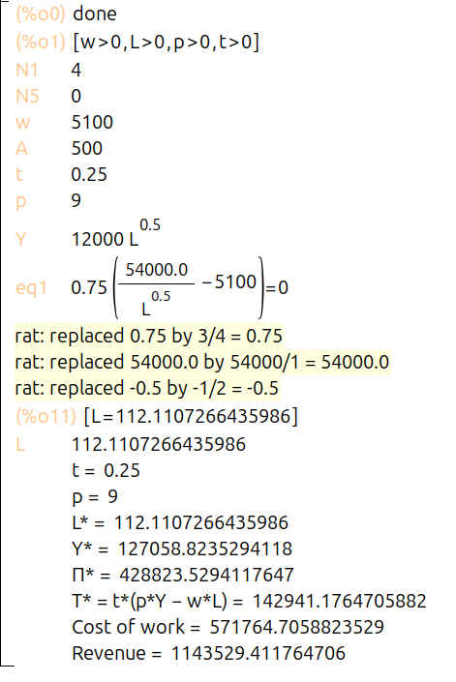 | kill(all);  assume(w >0,L>0,p>0,t>0);  N1:4;  N5:0;  w: 5100;  A:500;  t: 3;  p: (N1+ N5 + 5);  /* enter the production function */  Y: A*(N1+N5 + 20)*L^(0.5);  /* enter the profit function */  Profit: (p - t)*Y - w*L$  /* calculate f.o.c*/  eq1: diff(Profit,L,1) = 0;  float(solve (eq1,L));  L : rhs(%[1]);  /* outputs */  print("t = ", ''t) $  print("p = ", ''p) $  print("L* = ", ''L) $  print("Y* = ", ''Y) $  print("Π* = ", ''Profit) $  print("T* = t*Y* = ", '' t*''Y) $  print("Cost of work = ", '' w*L )$  print("Revenue = ", '' p*''Y) $  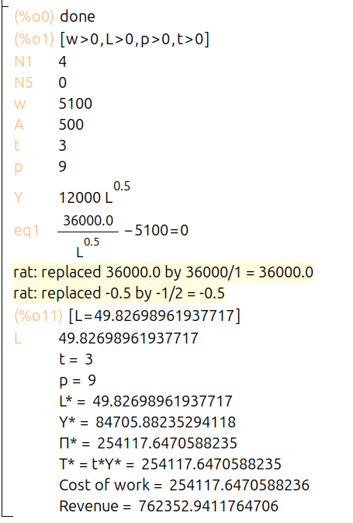 | kill(all);  assume(w >0,L>0,p>0,t>0);  N1:9;  N5:9;  w: 5100;  A:500;  t: 0.25;  p: (N1+ N5 + 5);  /* enter the production function */  Y: A*(N1+N5 + 20)*L^(0.5);  /* enter the profit function */  Profit: (1 - t)* (p*Y - w*L)$  /* calculate f.o.c*/  eq1: diff(Profit,L,1) = 0;  float(solve (eq1,L));  L : rhs(%[1]);  /* outputs */  print("t = ", ''t) $  print("p = ", ''p) $  print("L* = ", ''L) $  print("Y* = ", ''Y) $  print("Π* = ", ''Profit) $  print("T* = t*Profit* = ", '' t*''Profit) $  print("Cost of work = ", '' w*''L) $  print("Revenue = ", '' p*''Y) $  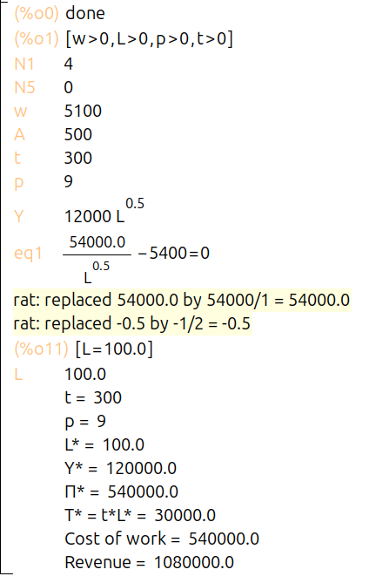

Analysis Advanced Microeconomics style:

Although we are using a Cobb-Douglas production function as a simplification, ideally, we should have a more general form of the production function that exhibits specific fundamental properties (see the lecture example from the textbook). Our objective is to derive and analyze a general solution in symbolic form. This will allow us to determine how our endogenous variables respond to exogenous factors (such as prices and taxes) or other parameters.

We aim to explore the effects of taxation on i) labour demand and ii) the supply of candy. In this case, we calculate Y as an indirect function of L* (by substituting the labour demand function into the production function). We will then examine the first derivative of this function with respect to the relevant variable.

Our focus will only be on analyzing the effects of the ad valorem sales tax on labour and production. Interpret the analytical result obtained.

Isn’t it helpful to have a shortcut similar to Hotelling’s Theorem? I won’t make you go through this type of analysis in every lecture, but just imagine what you're missing!

kill(all)$
assume(A>1,w >0,L>0,p>0,t>0, t<1, a>0,a<1)$
declare (a, noninteger)$
/* enter the production function */
Y: A*L^(a)$
/* enter the profit function */
Profit: p*(1-t)*Y - w*L$
/* calculate f.o.c*/
eq1: diff(Profit,L,1) = 0$
solve (eq1,L)$
L : rhs(%[1])$
L_star: ''L$
Y_star : ev(Y)$
print("L* = ", ''L_star) $
print("Y* = ", ''Y_star) $
print("dL*/dt = ", ''diff(L_star,t,1)) $
print("dY*/dt = ", ''diff(Y_star,t,1)) $

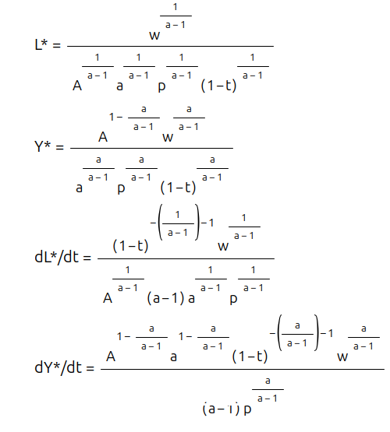

The Rule: The firm hires labor (L) until the money it gets from that labor (VMP_{L}) equals the wage (w).
The formula for VMP_{L} (Value of Marginal Product of Labor) is:
VMP_{L} = Price * MP_{L}
With the tax, the price the firm receives is p(1-t).
So, the firm's rule is: p(1-t) * MP_{L} = w.

How t Affects Labor ($L$):
- MP_{L} (Marginal Product of Labor) is A * a * L^{{a-1)}. Because a=0.5, MP_{L} gets smaller as L gets bigger (diminishing returns).
- Look at the rule: p(1-t) * MP_{L} = w.
- If the government increases the tax t, the p(1-t) part gets smaller.
- To keep the equation balanced, the MP_{L} must get bigger to make up for it.
- For MP_{L} to get bigger, labor (L) must get smaller.
- Conclusion: $\frac{dL}{dt}$< 0. Increasing the sales tax always decreases the demand for labor.
How t Affects Production (Y):
- The production function is Y = ALª.
- Since we just proved that (L) gets smaller, production Y must also get smaller.
- Conclusion: $\frac{dY}{dt}$ < 0 Increasing the sales tax always decreases production.

3) Application of Felix Klein's Postulates

Rather than focusing solely on theorems, proofs, or general results in symbolic form, you can experiment with models and attempt to address the fundamental question of external validity. The examination of internal validity can be found in advanced microeconomics textbooks.

This task involves a subjective assessment of whether the models are externally valid. The key takeaway is that the only definitive conclusions you can draw are whether something increases, decreases, or remains unchanged (the exact numbers are irrelevant). What truly matters is how the function behaves, as this reveals the underlying dynamics of the system.

kill(all);  assume(w >0);  N1:4;  N5:0;  p: (N1+ N5 + 5);  /* enter the production function */  Y: 500*(N1+ N5 + 20)*L^(0.5);  /* enter the profit function */  Profit: p*Y - w*L;  /* calculate f.o.c*/  eq1: diff(Profit,L,1) = 0;  float(solve (eq1,L));  L : rhs(%[1]);  draw2d(  xlabel = "w",  ylabel = "L",  explicit(ev(L), w,2000,8000));  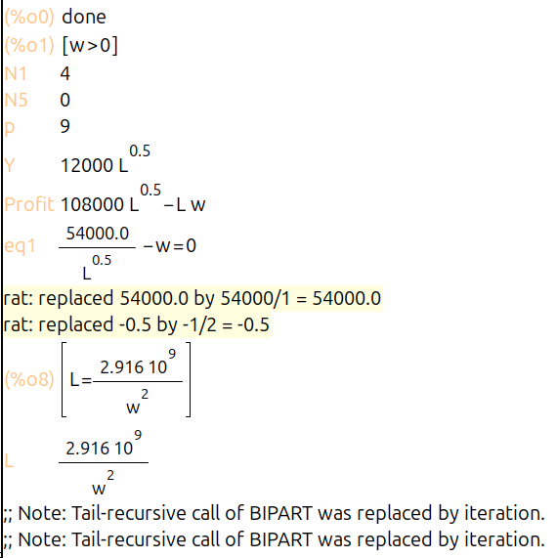  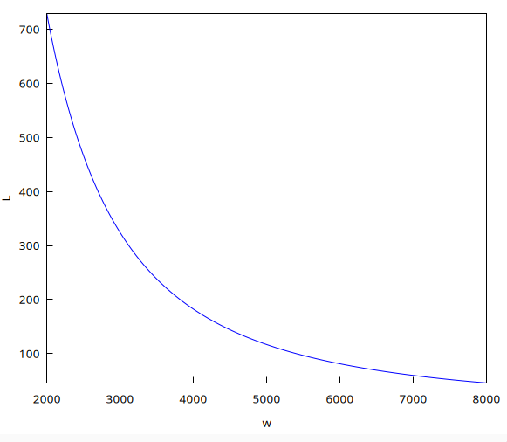  Labor L as a function of wage w This code shows that as wage (w) goes up, the company demands less labor (L). | kill(all);  assume(w >0);  N1:4;  N5:0;  p: (N1+ N5 + 5);  /* enter the production function */  Y: 500*(N1+ N5 + 20)*L^(0.5);  /* enter the profit function */  Profit: p*Y - w*L;  /* calculate f.o.c*/  eq1: diff(Profit,L,1) = 0;  float(solve (eq1,L));  L : rhs(%[1]);  /* calculate elasticity f(w)*/  e_L: diff(ev(L),w,1)* (w/L);  draw2d(  xlabel = "w",  ylabel = "Elasticity of L(w) with respect to w",  explicit(ev(e_L), w,2000,4000));  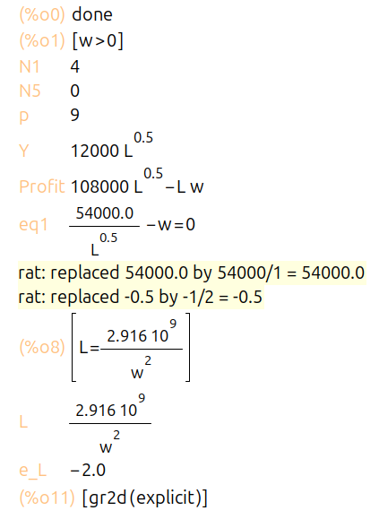  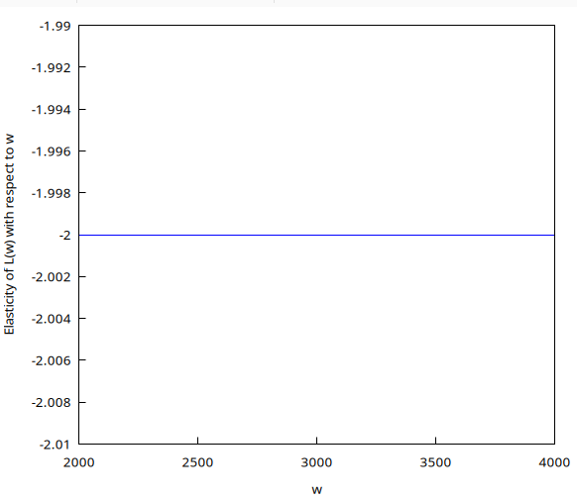  Elasticity of Labor L(w) This calculates the elasticity. For this model, the graph will show a constant line at -2. This means a 1% increase in wage (w) causes a 2% decrease in labor (L). | We can easily reverse the relation and analyze the demand for labour as a function of wages L(w). We can calculate and visualize the elasticity of labour E(w) with respect to wages (w).
kill(all);  assume(w >0);  assume(1- t >0);  N1:4;  N5:0;  w:5100;  p: (N1+ N5 + 5)*(1-t);  /* enter the production function */  Y: 500*(N1+ N5 + 20)*L^(0.5);  /* enter the profit function */  Profit: p*Y - w*L;  /* calculate f.o.c*/  eq1: diff(Profit,L,1) = 0;  float(solve (eq1,L));  L : rhs(%[1]);  draw2d(  xlabel = "t",  ylabel = "L",  explicit(ev(L), t,0,0.99));  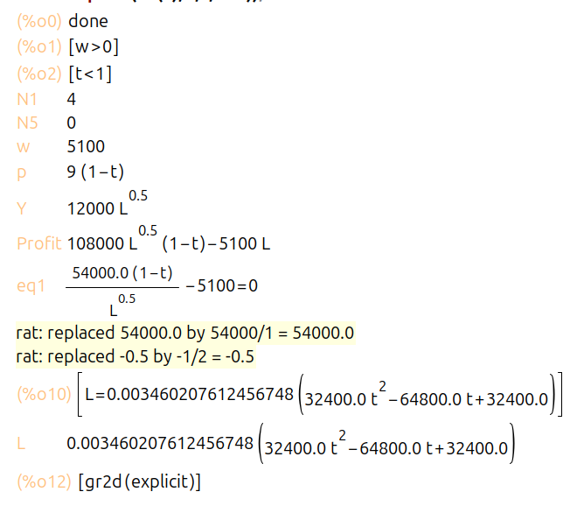  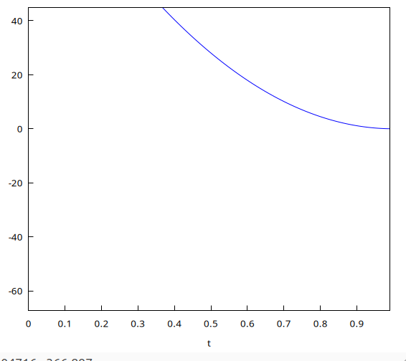  Labor L as a function of tax t This shows that as the sales tax (t) increases (from 0 to 1), the company demands less labor (L). | kill(all);  assume(w >0);  assume(1- t >0);  N1:4;  N5:0;  w:5100;  p: (N1+ N5 + 5)*(1-t);  /* enter the production function */  Y: 500*(N1+ N5 + 20)*L^(0.5);  /* enter the profit function */  Profit: p*Y - w*L;  /* calculate f.o.c*/  eq1: diff(Profit,L,1) = 0;  float(solve (eq1,L));  L : rhs(%[1]);  /* calculate elasticity f(w)*/  e_L_t: diff(ev(L),t,1)* (t/L);  draw2d(  xlabel = "t",  ylabel = "Elasticity of L(t) with respect to t",  explicit(ev(e_L_t), t,0,0.99));  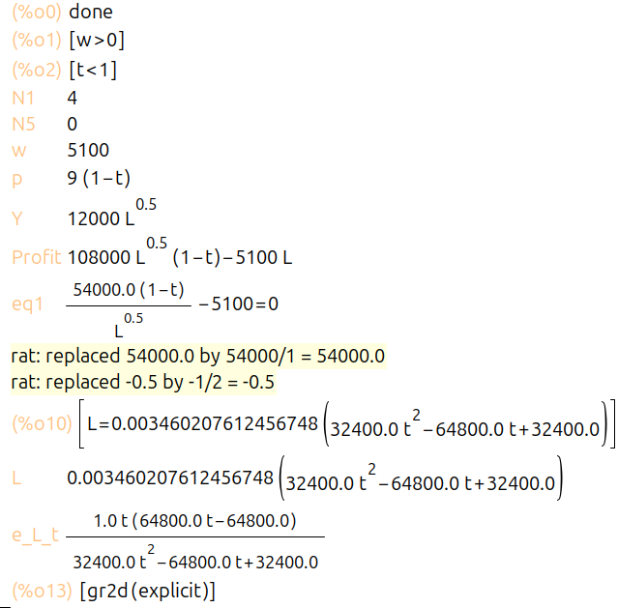  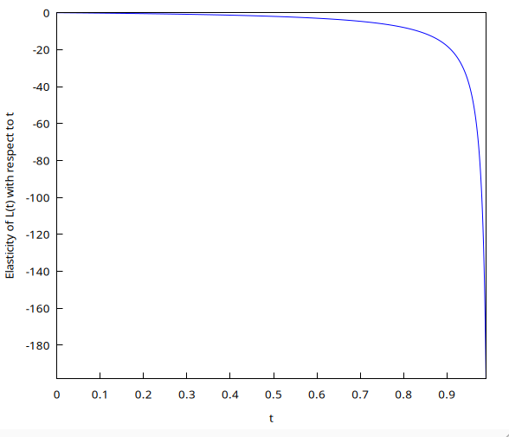  Elasticity of Labor L(t) This shows how sensitive labor demand is to the tax. The elasticity is negative and gets bigger (more negative) as the tax rate t increases. | How taxes influence demand for labour? We can calculate and visualize the elasticity of labour L(t) with respect to tax rate (t).  graphs 3 and 4 show that as the sales tax rate (t) increases, the demand for labor (L) decreases, and the elasticity graph further quantifies this negative relationship.
kill(all);  assume(w >0);  assume(1- t >0);  N1:4;  N5:0;  w:5100;  p: (N1+ N5 + 5)*(1-t);  /* enter the production function */  Y: 500*(N1+ N5 + 20)*L^(0.5);  /* enter the profit function */  Profit: p*Y - w*L;  /* calculate f.o.c*/  eq1: diff(Profit,L,1) = 0;  float(solve (eq1,L));  L : rhs(%[1]);  draw2d(  xlabel = "t",  ylabel = "Profit",  explicit(ev(Profit), t,0,0.99));  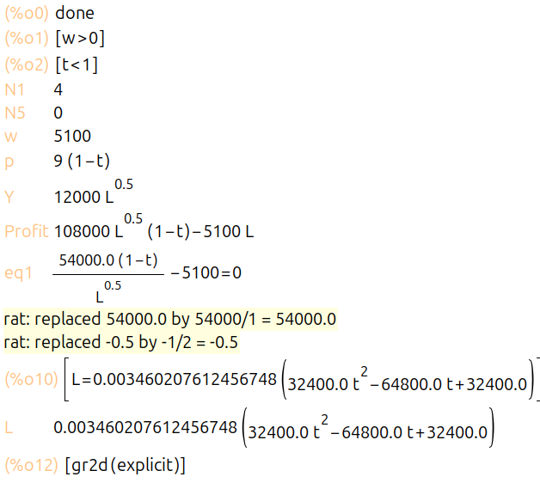  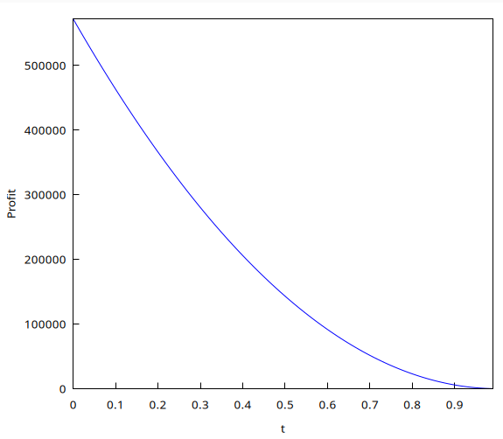  This graph shows that as the tax rate (t) increases, the company's profit (Pi) goes down. | kill(all);  assume(w >0);  assume(1- t >0);  N1:4;  N5:0;  w:5100;  p: (N1+ N5 + 5)*(1-t);  /* enter the production function */  Y: 500*(N1+ N5 + 20)*L^(0.5);  /* enter the profit function */  Profit: p*Y - w*L;  /* calculate f.o.c*/  eq1: diff(Profit,L,1) = 0;  float(solve (eq1,L));  L : rhs(%[1]);  draw2d(  xlabel = "t",  ylabel = "Y",  explicit(ev(Y), t,0,0.99));  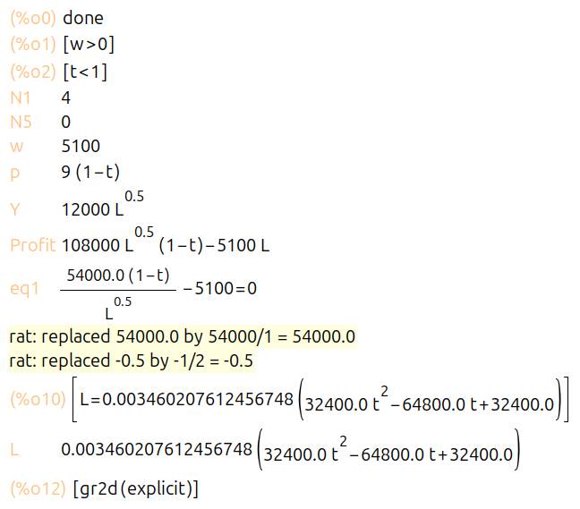  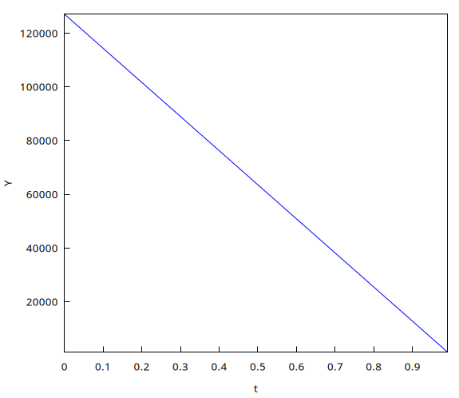  This graph shows that as the tax rate (t) increases, the company's production (Y) also goes down. | How taxes influence profit and production?  Graphs 5 and 6 (which you correctly identified) clearly show that as the sales tax rate (t) increases, both the company's profit (Pi) and its total production (Y*) steadily decrease.
kill(all);  assume(w >0);  assume(1- t >0);  N1:4;  N5:0;  w:5100;  /* p_market is the fixed price, p_firm is the price firm gets */  p_market: (N1+ N5 + 5);  p_firm: p_market*(1-t);  /* enter the production function */  Y: 500*(N1+ N5 + 20)*L^(0.5);  /* enter the profit function */  Profit: p_firm*Y - w*L;  /* calculate f.o.c*/  eq1: diff(Profit,L,1) = 0;  float(solve (eq1,L));  L : rhs(%[1]);  /* calculate tax revenue T(t) as a function of t */  /* T = tax_rate * market_price * Y_optimal */  T: t*p_market*ev(Y);  draw2d(  xlabel = "t",  ylabel = "T",  explicit(ev(T), t,0,0.99));  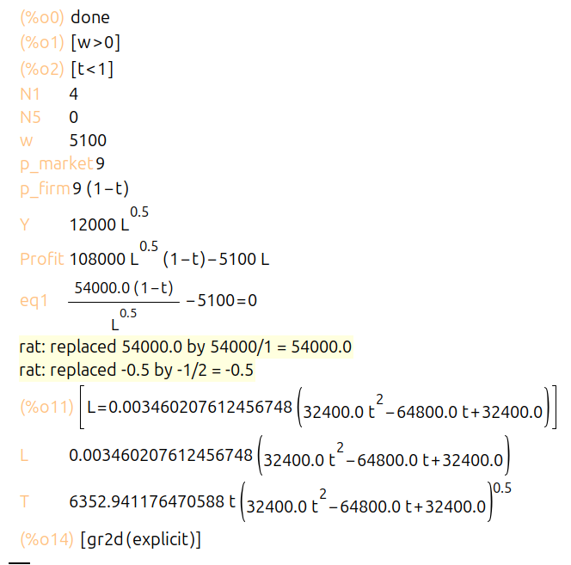  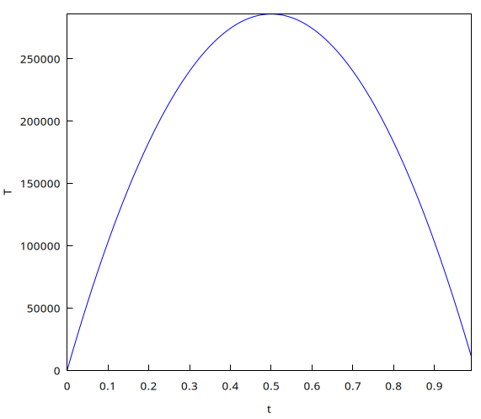  Tax revenue (T) first goes up as t increases, but then it goes down. Revenue is 0 at t=0 and t=1. The maximum revenue is at t=0.5 (or 50%). |  | It is a sort of Laffer curve. It is the tax revenue function T(t) with respect to the tax rate.
kill(all);  /* Corrected assumption: a is between 0 and 1 */  assume(A>1,w >0,L>0,p>0,t>0, t<1, a>0,a<1);  declare (a, noninteger)$  N1:4;  N5:0;  p: (N1+ N5 + 5);  w: 5100;  /* enter the production function */  Y: 500*(N1+ N5 + 20)*L^(a);  /* enter the profit function */  Profit: p*Y - ''w*L;  /* calculate f.o.c*/  eq1: diff(Profit,L,1) = 0;  /* Removed float() for symbolic solving */  solve (eq1,L);  L : rhs(%[1]);  draw2d(  xlabel = "a",  ylabel = "owner and labour incomes",  key = "labour expenses",  explicit(ev(w*''L), a,0.3,0.55),  key = "profit ",  color = red,  explicit(ev(''Profit), a,0.3,0.55)  );  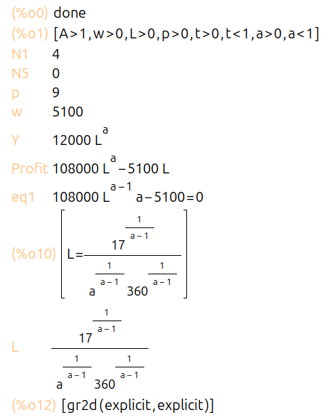  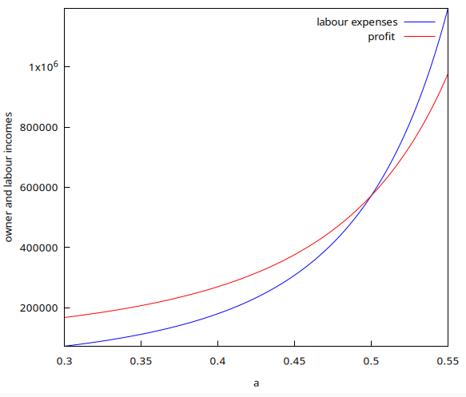  As the parameter 'a' (labor's importance) increases, the total money paid to labor (blue line) goes up, and the owner's profit (red line) goes down. |  | Finally, something to think about: how the division of income between owners and employees depends directly on the production function parameter. An interesting and very significant relationship.

